Git and GitHub challenge

Resolve Merge Conflicts
- Create a merge conflict intentionally (two users editing the same line).
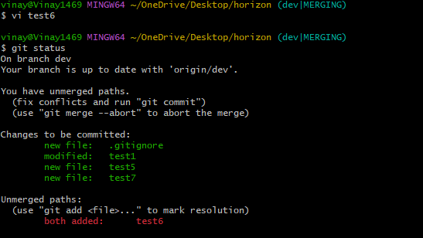
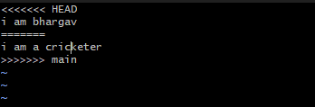
- Resolve the conflict and push the changes.
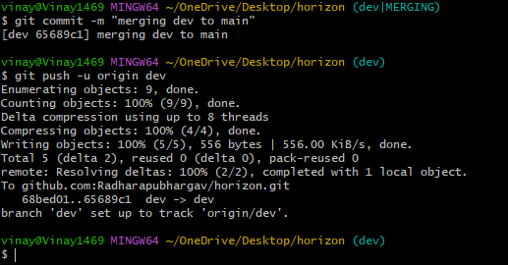

Recover Deleted Branch
- Delete a local branch and then recover it using the reflog.
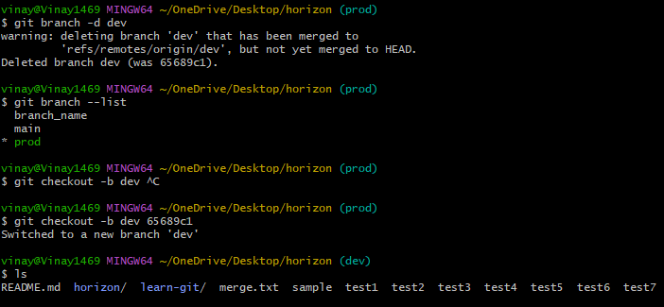
Undo Wrong Push
- Push a wrong commit to GitHub, then undo it without losing history.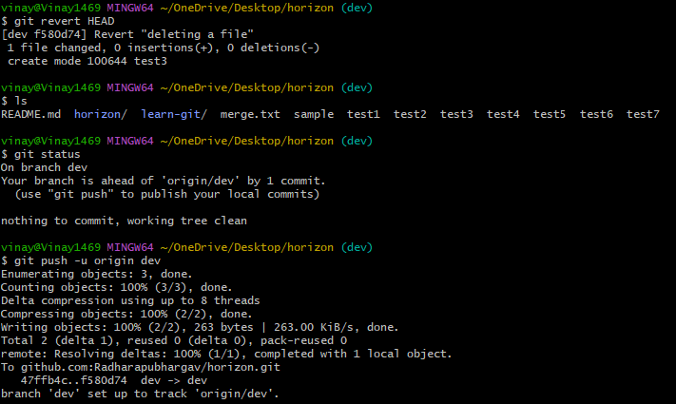
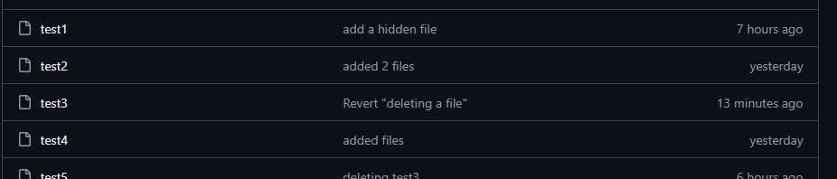
Amend a Commit
- Make a commit, then add a missing file to it using git commit --amend.
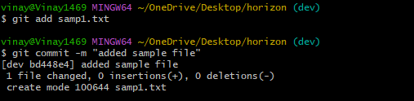
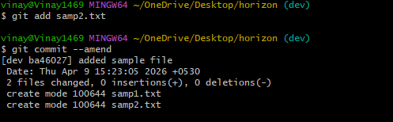

Cherry-pick a Commit
- Take a specific commit from one branch and apply it to another branch.
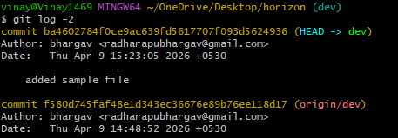
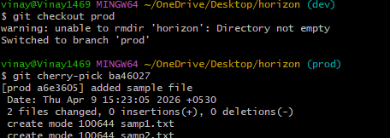
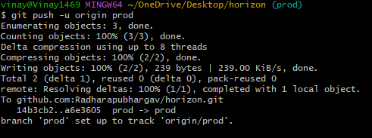

Interactive Rebase
- Reorder and squash multiple commits into a single clean commit.
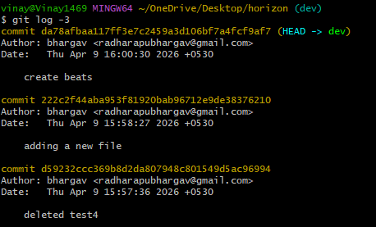
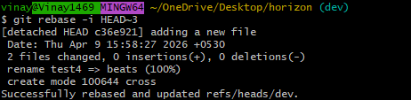
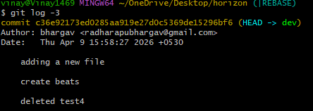

Tagging & Release
- Create a version tag (v1.0), push it to GitHub, then delete and restore it.
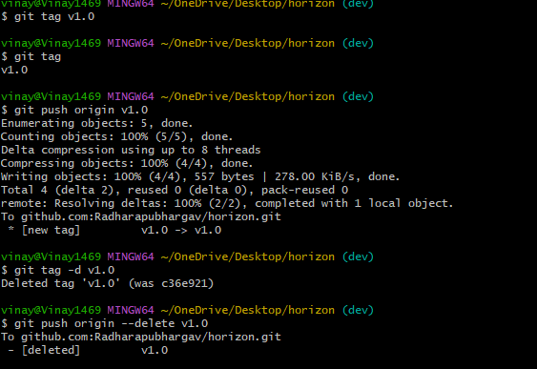
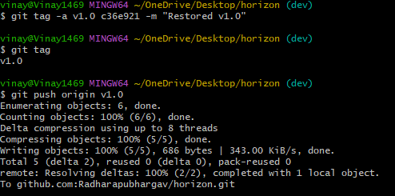
Clone with Sparse Checkout
- Clone only a subdirectory of a repo using sparse checkout.

Reset vs Revert Challenge
- Demonstrate the difference between git reset --hard and git revert in a repo.
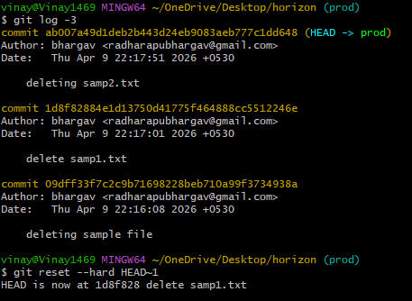
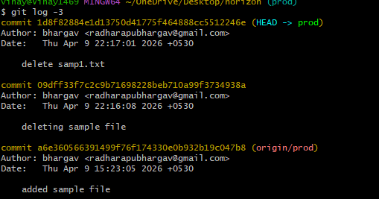
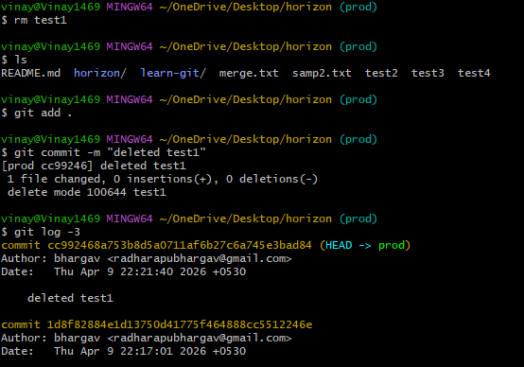
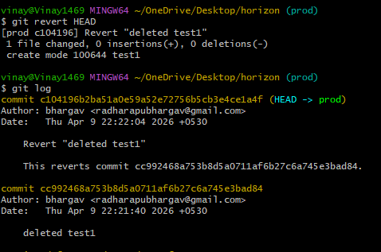
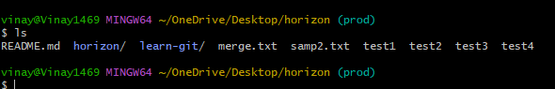

Detached HEAD Challenge
- Checkout a specific commit (detached HEAD state) and create a new branch from it.
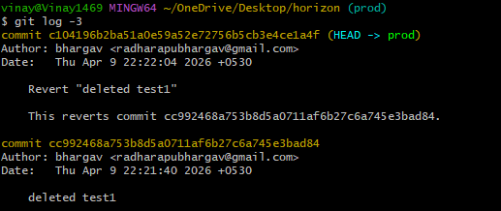
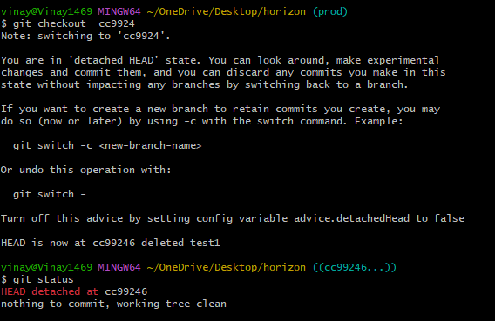
Git Hooks Challenge
- Configure a pre-commit hook to reject commits without a message format (e.g., must start with JIRA-XXX).
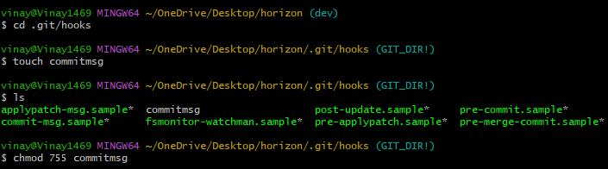
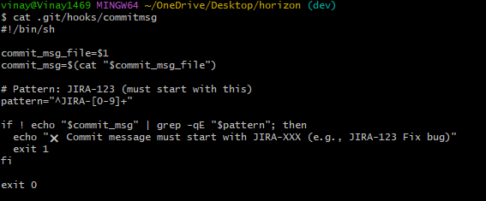
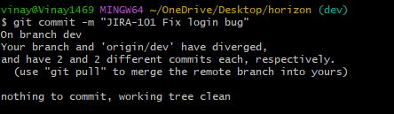
Squash Merge vs Rebase Merge
- Show the difference between squash merge and rebase merge with evidence.



Fork & Pull Request Workflow
- Fork a repo, make a change, and submit a pull request to the original repo.
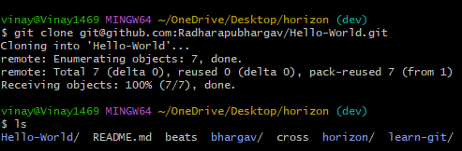
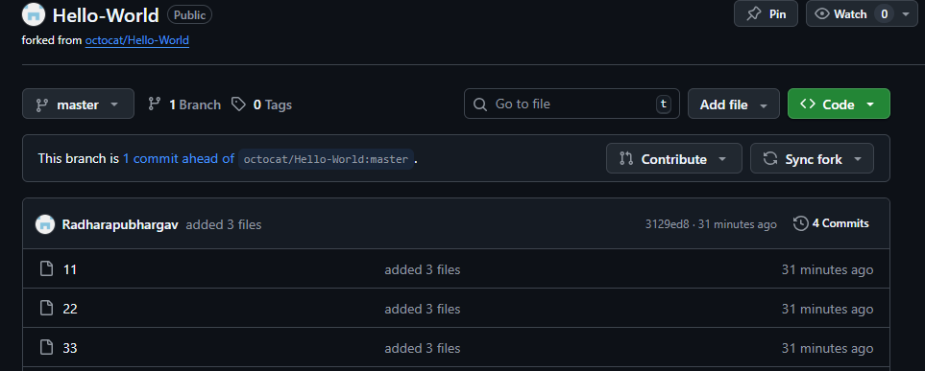

Recover Lost Commit
- Commit something, reset hard, and then recover it using git reflog
